U.P. Center for Ethnomusicology Access Policy & Procedures

Edited:
December 2010

Prepared by:
Grace Ann Buenaventura, Loen Vitto & Dayang Yraola

Reviewed by:
Atty. Vyva Aguirre, Dean & Prof. Elvira Torres Lapuz, SLIS

Approved by:
UPCE Advisory Board

Dr. Sergio S. Cao
Dr. Lorna I. Paredes
Dr. Eufracio Abaya
Dr. Jose S. Buenconsejo
Dr. Verne de la Peña
Dr. Ramon P. Santos
Ms. Marialita T. Yraola



U.P. Center for Ethnomusicology
Room 210-212, 218-220, Abelardo Hall, College of Music
University of the Philippines, Diliman, Quezon City 1101

Telefax: (+632) 9257139
Email: upethno@gmail.com
Website: http://beta.upethnom.com



University of the Philippines
CENTER FOR ETHNOMUSICOLOGY

ACCESS POLICIES
&
PROCEDURES

Service Hours:
Mondays to Fridays, 9:00am-4:00pm
Rooms 210-212; 218-220
Abelardo Hall, College of Music
University of the Philippines
Diliman, Quezon City

TABLE OF CONTENTS

- Introduction

- Facilities

- Service Functions

- Classification of Materials

- Policies and Procedures

- Who may Access the Collection

- Entry and Access Procedures

- General Access Policies

- Use of and Access to the Archive

- Schedule of Fees

ANNEXES

A. INTRODUCTION

The UP Center for Ethnomusicology (UPCE) houses a valuable collection of materials on the musical cultures of the Philippines and other parts of the world. The core collection comes from the research by its principal author, Jose Maceda, and his associates and assistants but it is continually being enriched by sources from local and international scholars. As per approval of the UP Board of Regents, in its 1110th meeting held on June 26, 1997, the UPCE is mandated to disseminate this knowledge to the public through education and other endeavours.

Dr. Jose Maceda (1917 – 2004) is an artist, ethnomusicologist, composer, philosopher, humanist, and scholar. His personal collections were officially transferred and deposited at the UP Center for Ethnomusicology (formerly Department of Asian Music and the Department of Music Research) on September 22, 2005. They are now referred to as the Jose Maceda Collection. In August 2007, the collection was added to UNESCO’s Memories of the World Register, an item of documentary heritage of exceptional value. The Center is presently located at the second floor, Main Building of the U.P. College of Music, Abelardo Hall, Diliman, Quezon City.

The general book collection, serials, theses and dissertations, music scores, two & three dimensional objects (photographs, slides, posters, instruments, etc.), vertical file collection, field notes & sound recordings, video tapes and films are mainly concerned with the musics of the world’s cultures with emphasis on traditional and ethnic repertoires, as well as orally transmitted folk sound expressions in the Philippines and Southeast Asia. Other subject areas from the book collection are philosophy, religion, history, anthropology, linguistics, mathematics, and literature in which majority of the collection are written in international languages such as Filipino, French, German, Dutch, Spanish, Italian, Portuguese, Chinese, Indonesian, Japanese, Korean, Indian, Thai, Malay, Burmese, Vietnamese, Arabic, Russian, and English.

The collection includes a variety of Philippine gongs, and bamboos and some aerophones, chordophones, idiophones, and membranophones from other Asian countries (Thailand, China, India, Japan, Korea, Indonesia, etc.) as well as parts of Latin America and Africa.

As a repository of knowledge about musical traditions and cultures, the UPCE safeguards the ownership of the collection which belongs to the researchers and donors, but most of all, to the artists whose voices and music are contained in the materials and are documented. It seeks to preserve and protect the materials from unscrupulous users. In line, however, with its mandate, it encourages scholars and advanced students to access the collection for research purposes and for other projects in knowledge building conducted in collaboration with the UPCE. It aims to perpetuate and harness its collection to generate musical and music-related knowledge and materials from an interdisciplinary perspective through academic study, pedagogy, artistic production and other applications.

In particular, the UPCE assist scholars (representing disciplines in the humanities and the social sciences), composers, serious artists and pedagogues in music, who share in its vision and goals to:
1. Link up with the centers of ethnomusicological research in Asia and the western hemisphere;

2. Search for the fundamental musical structure of the musics of Asia and their relationship to society and culture in Asia and in other parts of the world;

3. Generate new theories of music and music composition;

4. Collaborate with the disciplines of archaeology, anthropology, linguistics and mathematics on any aspect of ethnomusicological research;

5. Act as a source of ideas for changes in the field of music pedagogy and music education as applied in modern institutions of learning.

The principal activities of the UP Center for Ethnomusicology:
1. Academic and applied music research; course requirements

2. Publication of Musika Jornal and other scholarly works

3. Continuing individual and collaborative field and archival research

B. FACILITIES

1. Card catalogues of print materials arranged alphabetically by author and subject for library materials, in accordance to the Library of Congress Classification System (LCCS)

2. Card catalogue with special classification system for the instruments and audio materials (tape collection)

3. Collection catalogue through I-Lib

4. Open stacks

5. Reading area

6. Access station for digitized data for fieldnotes, photographs and audio field recordings.

C. SERVICE FUNCTIONS

1. Reference Library

2. Instruments for viewing and loan

3. Music scores for reading and loan

4. Digital manuscripts and photographs databank

5. Digital audio databank

6. Archiving/storage of materials in various media/format

7. Field research

8. Special projects
D. CLASSIFICATION OF MATERIALS

1. Archive

1.1. Field / Sound Recordings
- Collected by Jose Maceda

- Collected as sponsored and funded by the UPCE

- Collected with assistance from the UPCE

- Collected in cooperation with the UPCE

- Copies of collection by other researchers outside the UPCE

1.2. Field Notes, Field Photographs and Other Two-dimensional Materials
- Collected by Jose Maceda

- Collected as sponsored and funded by the UPCE (formerly Department of Asian Music and the Department of Music Research)

- Collected with assistance from the UPCE

- Collected in cooperation with the UPCE

- Copies of collection by other researchers outside the UPCE

1.3. Musical Instruments
- Archival and field collection

- Acquired through purchase by the UPCE

- Donated to the UPCE

1.4. Musical Scores
- Unpublished

- Published

1.5. Memorabilia

1.6. Miscellaneous

2. LIBRARY

2.1. Books, Periodicals, Theses, Journals
- Published or produced by the UPCE

- Acquired through purchase by the UPCE

- Donated to the UPCE

2.2. Published Recordings (LP’s, CD’s, Cassettes)
- Published or produced by the UPCE

- Acquired through purchase by the UPCE

- Donated to the UPCE

E. POLICIES AND PROCEDURES
1. Who may access the collection
The UP Center for Ethnomusicology collection shall be open for the use of the following
parties:
1.1. The faculty, students and staff (permanent, contractual) who are currently employed or enrolled at all units in the University of the Philippines;

1.2. Students, scholars, and members of cultural institutions from the Philippines and abroad;

1.3. Individual scholars and artists doing cooperative study and research with the UPCE;

1.4. Consultants and Informants and resource persons for specific research areas such as musicology, anthropology, sociology, art studies, philosophy, linguistics, Asian studies, Philippine studies, cultural studies, archaeology, history, library science, audio engineering and electrical and electronic engineering of universities, colleges, research centers and cultural centers;

1.5. UPCE Fellows (to be established later);

1.6. Educational groups (for visits only).

N.B. The UPCE shall be confined to academic study as well as purely scholarly or creative purposes. The UPCE reserves the right to refuse access to the collection for extra-academic or extra-scholarly purposes.

2. Entry and Access Procedures
The requirements for entry to the archives are as follows

3. General Access Policies
2.1. General Entry Requirements
 | UP Diliman Student/  Faculty | Other UP Student/  Faculty | UP Alumni | Non UP | Foreign Partner | Other Foreign
Valid ID | UP ID | UP ID | UP ID | 2 valid IDs | 2 valid IDs | 2 valid IDs
Request for use of archive w/ endorsement | Endorsed by Dean or unit Head Librarian | Endorsed by Dean or unit Head Librarian | Endorsed by Dean or unit Head Librarian | Endorsed by Dean or unit Head Librarian | Endorsed by Dean or unit Head Librarian | Endorsed by Dean or unit Head Librarian
Registration form ANNEX1 | 1 working day before visit to ensure availability of staff assistance & user space | 1 working day before visit to ensure availability of staff assistance & user space | 1 working day before visit to ensure availability of staff assistance & user space | 2 working days before visit for Executive Director’s approval | 5 working days before visit for Executive Director’s approval | 5 working days before visit for Executive Director’s approval
Fee | Php 50.00 | Php 50.00 | Php 50.00 | Php 150.00 | Free | Php 500.00
3.1. Users must sign the library attendance sheet.

3.2. Smoking, eating, drinking, sleeping, loitering and accessing internet which are not research related are NOT permitted in the UPCE under any circumstances.

3.3. Books, magazines, coats, brief cases, bags, folders, envelopes, or enclosed containers must be deposited at the designated space at the entrance.

3.4. Mobile phones must be turned off or placed on silent mode and deposited before using the facilities. In case you are expecting an emergency call, please inform the librarian.

3.5. Only laptops are allowed to be carried inside the UPCE.

3.6. Biros, fountain pens, felt tips and other pens and corrective fluids are not to be used. Pencil and paper are available at the reading areas.

3.7. Researchers must handle all records carefully and not mark, fold, tear or harm the records in any way.

3.8. The staff always welcomes information about cataloguing deficiencies, but under no circumstances shall the researcher rearrange manuscript materials or disturb the physical arrangement of individual pieces of manuscript and others. Any damage found in the material should be immediately reported to the staff before use.

3.9. Published materials are to be requested from the librarian.

3.10. No material is to be removed from the research room. Copying of materials in any form and all circumstances should be done through the assistance of the librarian.

3.11. Group tours or class visits must be arranged at least two (2) working days prior to the visit.

3.12. Researchers must respect conventions of courtesy and, where possible, silence.

3.13. UPCE staff are tasked to assist the researcher but also reserve the right to observe and monitor the handling of the materials for their physical protection and proper use.

3.14. The researcher must “log-out” in the library attendance sheet.

Violation of any of the above policies and provisions shall constitute ground for curtailing and denying future access to the collection of the UP Center for Ethnomusicology.

4. Use of and Access to Archive Materials
All archival materials may be accessed for ethnomusicology and/or related subjects with a clear academic/creative purposes. In view, the UPCE and the providence of unpublished materials must be duly acknowledged in all research outputs resulting therefrom. Specific conditions apply to specific types of data. Conditions are as follows:

4.1 Fill-out the Access form ANNEX2/ Borrower’s form for your requests
 | UP Diliman Student/  Faculty | Other UP Student/  Faculty | UP Alumni | Non UP | Foreign Partner | Other Foreign
Instrument | 1 hour before pull-out | NA | NA | NA | NA | NA
Audio file | 1 hour before use | 1 hour before use | 1 day before use | 1 day before use | 1 day before use | 1 day before use
Scores for browsing | 1 hour before use | 1 hour before use | 1 day before use | 1 day before use | 1 day before use | 1 day before use
Fieldnotes/photo | 1 day before use | 1 day before use | 1 day before use | 1 day before use | 2 days before use | 2 days before use
Requested reproduction/copies of audio file, score, and photograph shall be released one (1) working day after the request has been made. Specific requirements and fees may apply. Refer to tables 4.9; 4.10; 4.12; 4.13, and 5.1.

N.B. All requirements below are in addition to general entry requirements (table 2.1).

4.2 Requirements for borrowing instruments for classroom use within UP College of Music
UP Diliman Student/  Faculty | Other UP Student/  Faculty | UP Alumni | Non UP | Foreign Partner | Other Foreign
Borrower’s Form ANNEX3 | Borrower’s Form for Executive Director’s Approval | Borrower’s Form for Executive Director’s Approval | Borrower’s Form for Executive Director’s Approval | Not allowed | Not allowed
ID of user (to be deposited at the UPCE while the instrument is out) | ID of user (to be deposited at the UPCE while the instrument is out) | ID of user (to be deposited at the UPCE while the instrument is out) | ID of user (to be deposited at the UPCE while the instrument is out)
 |  | Fees | Fees

4.3 Requirements for borrowing instruments for classroom use outside the UP College of Music (i.e. Arts and Sciences classes)
UP Diliman Student/  Faculty | Other UP Student/  Faculty | UP Alumni | Non UP | Foreign Partner | Other Foreign
Request letter | (Inside UP Diliman only)  Request letter endorsed by Unit Dean or UP College of Music Faculty | Not allowed | Not allowed | Not allowed | Not allowed
Borrower’s Form for Executive Director’s Approval | Borrower’s Form for Executive Director’s Approval

4.4 Requirements for borrowing instruments for other activities within the UP College of Music
UP Diliman Student/  Faculty | Other UP Student/  Faculty | UP Alumni | Non UP | Foreign Partner | Other Foreign
Request letter | Not allowed | Not allowed | Not allowed | Not allowed | Not allowed
Borrower’s Form for Executive Director’s Approval
ID of user (to be deposited at the UPCE while instrument is out)
Fees

4.5 Requirements for borrowing instruments for other activities outside the UP College of Music
UP Diliman Student/  Faculty | Other UP Student/  Faculty | UP Alumni | Non UP | Foreign Partner | Other Foreign
Request letter
Borrower’s Form for Executive Director’s Approval | Not allowed | Not allowed | Not allowed | Not allowed | Not allowed
Fees
Contract with institution, organization or group who will use the instrument

4.6 Requirements for borrowing copy/copies of score for classroom use within the UP College of Music
UP Diliman Student/  Faculty | Other UP Student/  Faculty | UP Alumni | Non UP | Foreign Partner | Other Foreign
Request letter | Request letter | Request letter from institution | Request letter from institution | Request letter from institution | Request letter from institution
Score borrower’s form ANNEX4 | Score borrower’s form | Score borrower’s form | Score borrower’s form | Score borrower’s form | Score borrower’s form

4.7 Requirements for reproduction of score
UP Diliman Student/  Faculty | Other UP Student/  Faculty | UP Alumni | Non UP | Foreign Partner | Other Foreign
Request letter | Request letter | Request letter from Head of Institution | Request letter from Head of Institution | Request letter endorsed by the Head partner Institution | Request letter from Head of Institution
Request for reproduction form ANNEX5 | Request for reproduction form | Request for reproduction form | Request for reproduction form | Request for reproduction form | Request for reproduction form
Fees | Fees | Fees | Fees | Fees | Fees
Contract | Contract | Contract | Contract | Contract | Contract

4.8 Requirements for access of unpublished collection inside UPCE reading area
UP Diliman Student/  Faculty | Other UP Student/  Faculty | UP Alumni | Non UP | Foreign Partner | Other Foreign
Registration Form (for first time user only) | Registration form (w/ description of proposed work) | Request letter endorsed by unit head | Request letter endorsed by unit head | Request letter endorsed by unit head | Request letter endorsed by unit head
Access Form | Access Form | Registration form (w/ description of proposed work) for Executive Director’s approval | Registration form (w/ description of proposed work) for Executive Director’s approval | Registration form (w/ description of proposed work) for Executive Director’s approval | Registration form (w/ description of proposed work) for Executive Director’s approval
 |  | Access Form | Access Form | Access Form | Access Form
 |  | Fees | Fees | Fees | Fees

4.9 Requirements for acquiring print-out of unpublished collection for classroom use (for photographs only: maximum of 5 images per research day. Print-out of scores, fieldnotes, theses is not allowed for JM Collection )
UP Diliman Student/  Faculty | Other UP Student/  Faculty | UP Alumni | Non UP | Foreign Partner | Other Foreign
Request for reproduction form w/ Executive Director’s approval | Request for reproduction form w/ Executive Director’s approval | Request for reproduction form w/ Executive Director’s approval | Request for reproduction form w/ Executive Director’s approval | Request for reproduction form w/ Executive Director’s approval | Request for reproduction form w/ Executive Director’s approval
Contract | Contract | Contract | Contract | Contract | Contract
Fees | Fees | Fees | Fees | Fees | Fees

4.10 Requirements for acquiring print out of unpublished collection for research/creative work (for JM Collection only)
UP Diliman Student/  Faculty | Other UP Student/  Faculty | UP Alumni | Non UP | Foreign Partner | Other Foreign
Request for reproduction form w/ Executive Director’s approval | Request for reproduction form w/ Executive Director’s approval | Request for reproduction form w/ Executive Director’s approval | Request for reproduction form w/ Executive Director’s approval | Request for reproduction form w/ Executive Director’s approval | Request for reproduction form w/ Executive Director’s approval
Contract | Contract | Contract | Contract | Contract | Contract
Fees | Fees | Fees | Fees | Fees | Fees

4.11 Requirements for access of audio file inside UPCE
UP Diliman Student/  Faculty | Other UP Student/  Faculty | UP Alumni | Non UP | Foreign Partner | Other Foreign
Registration Form (for first time user only) | Registration Form (for first time user only) | Request letter endorsed by Unit Dean | Request letter endorsed by Unit Dean | Request letter endorsed by Unit Dean | Request letter endorsed by Unit Dean
Access Form | Access Form | Registration form (with  description of proposed work) for Executive Director’s approval | Registration form (with  description of proposed work) for Executive Director’s approval | Registration form (with  description of proposed work) for Executive Director’s approval | Registration form (with  description of proposed work) for Executive Director’s approval
ID of user | ID of user | Access Form | Access Form | Access Form | Access Form
 | Fees | ID of user | ID of user | ID of user | ID of user
 |  | Fees | Fees | Fees | Fees

4.12 Requirements for acquiring copy of audio file for classroom use: maximum of 60 seconds per track, maximum of 10 tracks per research day
UP Diliman Student/  Faculty | Other UP Student/  Faculty | UP Alumni | Non UP | Foreign Partner | Other Foreign
Request for reproduction form w/ Executive Director’s approval | Request for reproduction form w/ Executive Director’s approval | Request for reproduction form w/ Executive Director’s approval | Request for reproduction form w/ Executive Director’s approval | Request for reproduction form w/ Executive Director’s approval | Request for reproduction form w/ Executive Director’s approval
Contract | Contract | Contract | Contract | Contract | Contract
Fees | Fees | Fees | Fees | Fees | Fees

4.13 Requirements for acquiring copy of audio file for research/creative work (for JM Collection only): maximum of 60 seconds per track, maximum of 10 tracks per research day
CMu Student | CMu Faculty | Other UP | Non UP | Foreign Partner | Other Foreign
Request for reproduction form w/ Executive Director’s approval | Request for reproduction form w/ Executive Director’s approval | Request for reproduction form w/ Executive Director’s approval | Request for reproduction form w/ Executive Director’s approval | Request for reproduction form w/ Executive Director’s approval | Request for reproduction form w/ Executive Director’s approval
Contract | Contract | Contract | Contract | Contract | Contract
Fees | Fees | Fees | Fees | Fees | Fees

4.14 Requirements for transfer of audio and video materials to digital format
UP Diliman Student/  Faculty | Other UP Student/  Faculty | UP Alumni | Non UP | Foreign Partner | Other Foreign
Request for transfer form ANNEX 6 | Request for transfer form | Request for transfer form | Request for transfer form | Request for transfer form | Request for transfer form
Fees | Fees | Fees | Fees | Fees | Fees

4.15. On no occasion shall original material be accessed without written permission from the Executive Director.

4.16. All published reading materials are for room use only. Duplication is considered only if the proposed copying does not breach the provisions of Part IV (Copyright) of Republic Act No. 8293 (1996), otherwise known as the Intellectual Property Code of the Philippines.

4.17. In the absence of the Executive Director, approval of the Officer-in-charge or two Advisory Board Members is required.

4.18. The UPCE shall be given a copy of outputs as well as field recordings and other documentations accomplished by the researcher relative to the materials that have been accessed from/through the UPCE. They shall become part of the UPCE’s collection and shall be managed according to the policies of the UPCE and other pre-agreed conditions.

4.19. The UP Center for Ethnomusicology must be duly acknowledged for any form of data accessed in the UPCE in all outputs produced for public dissemination and consumption.
4.20. Contracts ANNEX7

In summary of the access matrix (4.1-4.14) the following contracts shall be accomplished
in connection with the data lending or reproduction:
- Use of instruments for other activities outside College of Music (for for CMu Faculty only)

- Use of scores for demonstration or presentation only (CMu student, faculty, other UP & foreign partner only)

- Use of scores for performance (for CMu student, faculty, other UP & foreign partner only)

- Use of unpublished photo for presentation (for all users)

- Use of unpublished photo for publication (for all users)

- Use of audio file for presentation (for all users)

- Use of audio file for recording/production (for all users)

Library and Archive users who have the intention to reproduce or borrow any of the UP Center for Ethnomusicology data are encouraged to review the contract prior to request for reproduction.

5. Schedule of Fees
All fees are in Philippine Peso (PhP)

5.1 Fees for Access ANNEX8
Product/Service | UP |  | Non-UP | Foreign
 | Classroom use | Non-Class use/ UP Alumni
Access Fees (access only) | Free | 50/visit | 200/appointment | 500/appointment

5.2 Fees for Borrowing of Instruments ANNEX9
Product/Service | UP |  | Non-UP | Foreign
Instruments | Classroom Use | Non-Class use/ Alumni
Bamboo & wood | Free | 20% of the cost of instrument per use | 30% of the cost of instrument per use | Not allowed
Brass/ Metal (Tamtam/gangsa/gong) | Free | 20% of the cost of instrument per use | 30% of the cost of instrument per use | Not allowed
String | Free | 20% of the cost of instrument per use | 30% of the cost of instrument per use | Not allowed

5.3Fees for Reproduction of scores ANNEX10
 | UP |  | Non-UP | Foreign
Reproduction of Scores | Classroom Use | Non-Class Use/ Alumni
Full score | Printing cost +100 | Printing cost +300 | Printing  cost +500 | Printing cost +1,000 (non-partners)  +500 for partners*
Part scores (1 copy for each part) | Printing cost +100 | Printing cost +300 | Printing cost +500 | Printing cost +1,000  +500
Published page (photocopy per page; maximum of 10 pages per research day) | 1.00 | 1.50 | 2.00 | 2.00

5.4Fees for Reproduction of Photographs ANNEX11
Photo | UP |  | Non-UP | Foreign
 | Classroom use | Non-class/ Alumni
Black & white print out (per image) | 2.00 | 5.00 | 10.00 | 10.00  5.00 for partners
Color print out (per image) | 5.00 | 10.00 | 15.00 | 15.00  10.00 for partners

5.5Fees for Reproduction of Audio Recording from UPCE ANNEX12
Reproduction of Audio Recording from UPCE Collection | UP |  | Non-UP | Foreign
 | Classroom | Non-Class Use/ Alumni
Field recording (for every 60secs) | 50 | 100 | 150 | 1000  500 for partners
Composition (Maceda, Santos, etc) (for every 60secs) | 50 | 100 | 150 | 1000  500 for partners
Published music (for every 60secs) | 20 | 50 | 100 | 1000  500 for partners

5.6Fees for Transfer of Audio Materials to Digital Format ANNEX13
 | UP |  | Non-UP | Foreign
Audio transfer | Classroom Use | Non-Class Use/ Alumni
Field recording and other documentation (recitals, meetings, concert)  (for every 60 secs) | 30 | 40 | 100 | 150  100 for partner
Commercial (for every track) | 30 | 40 | 100 | 150  100 for partner
platform: LP, open reel, cassette, dat, digital

5.7Fees for Transfer of Video Materials to Digital Format ANNEX14
 | UP |  | Non-UP | Foreign
Video transfer | Classroom | Non-Class Use/ Alumni
Field recording and Other documentation (recitals, meetings, concert)  (for every 60 secs) | 100 | 150 | 200 | 500  300 for partners
Commercial (for every film) | 80 | 100 | 300 | 500  300 for partners
Platform: VHS,hi8, V8, minidivi
*Partners are institutions or individuals that are members of LaonLaon Network (Network of Music Research Centers in Asia)
*machine may not be available; user may bring own playback machine

ANNEXES
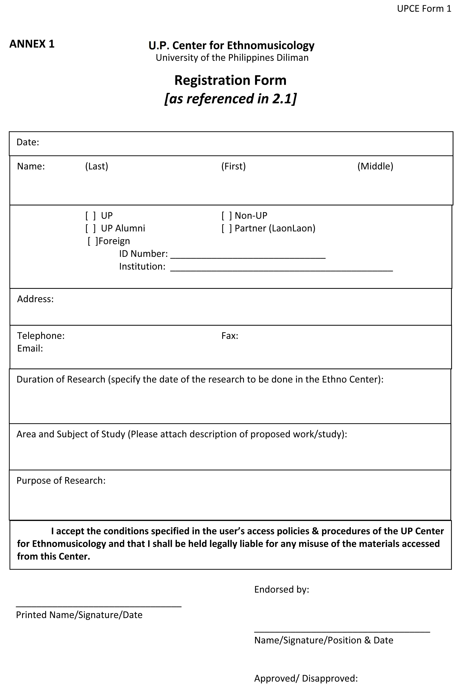
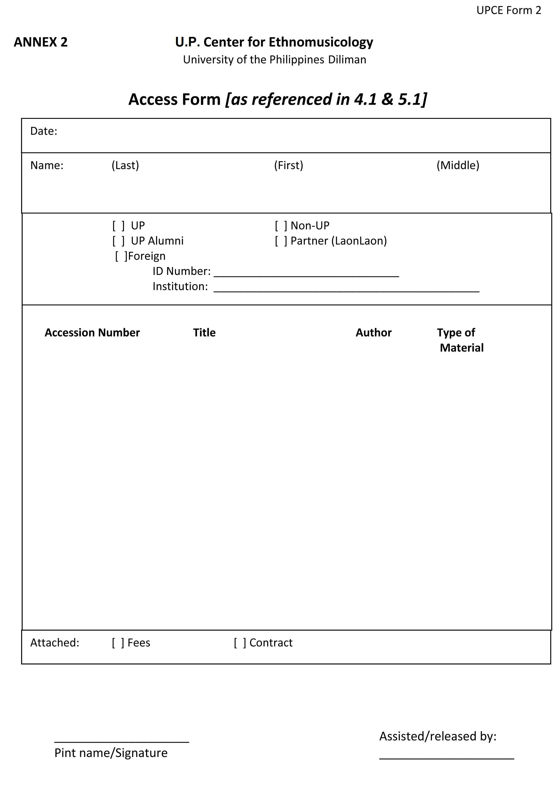
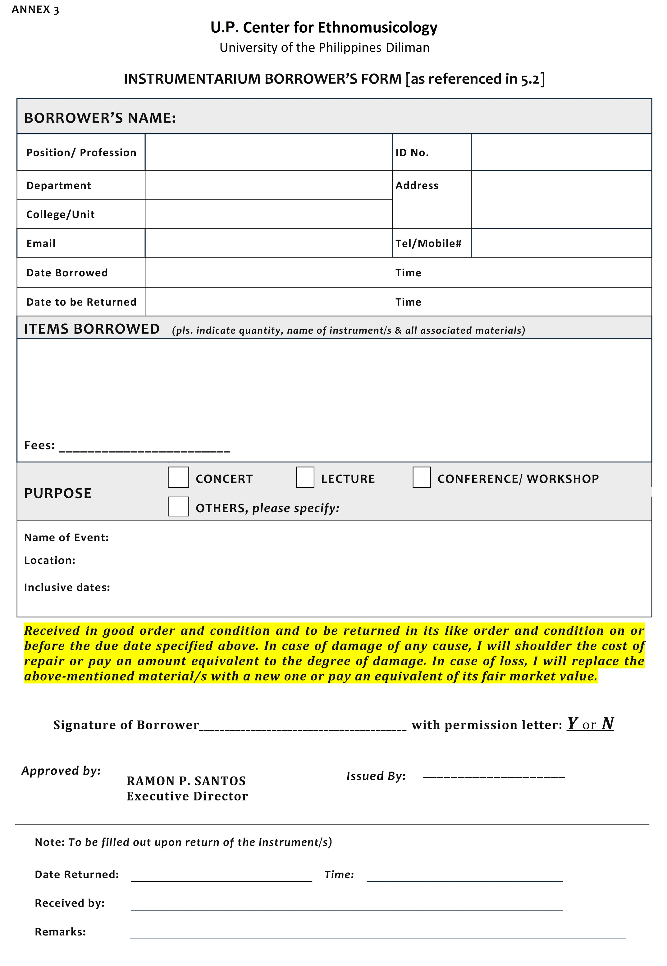

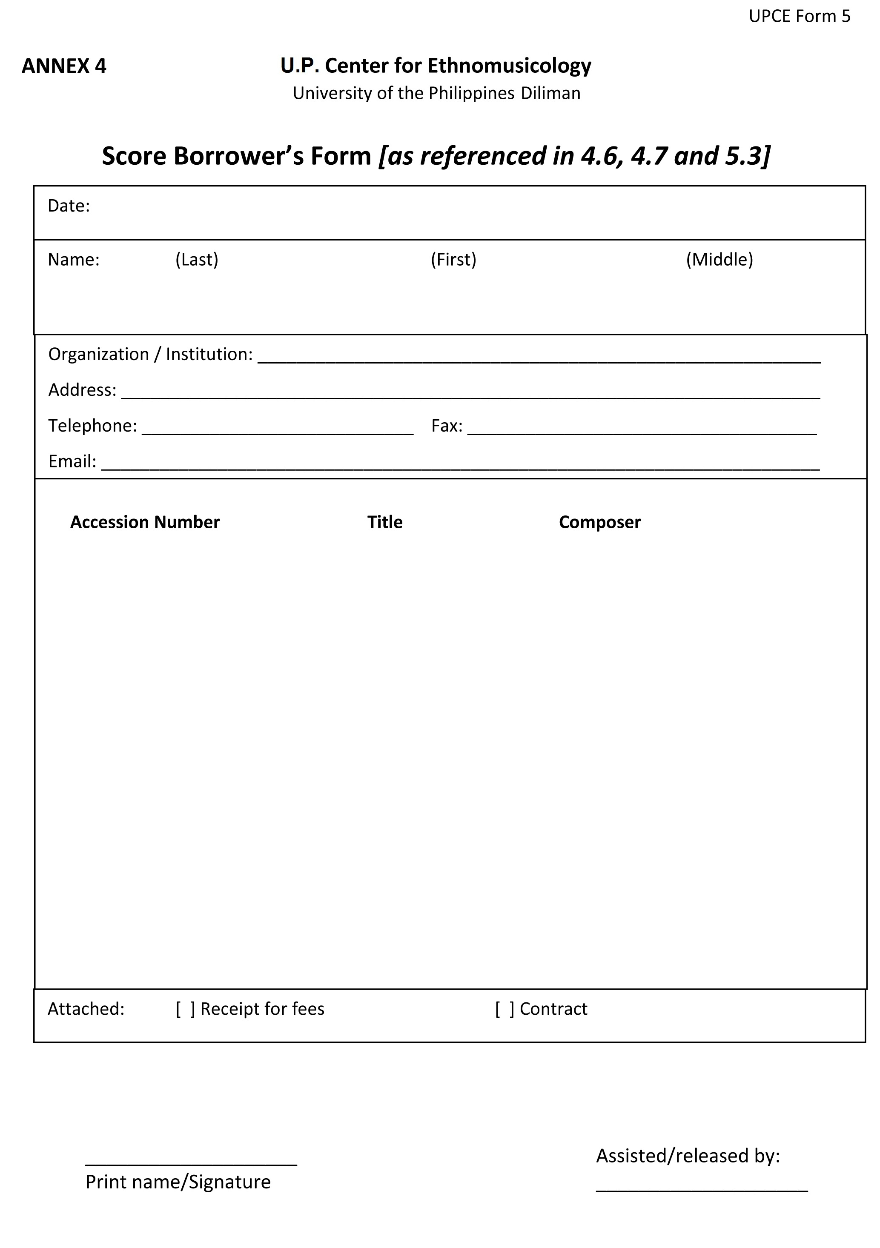

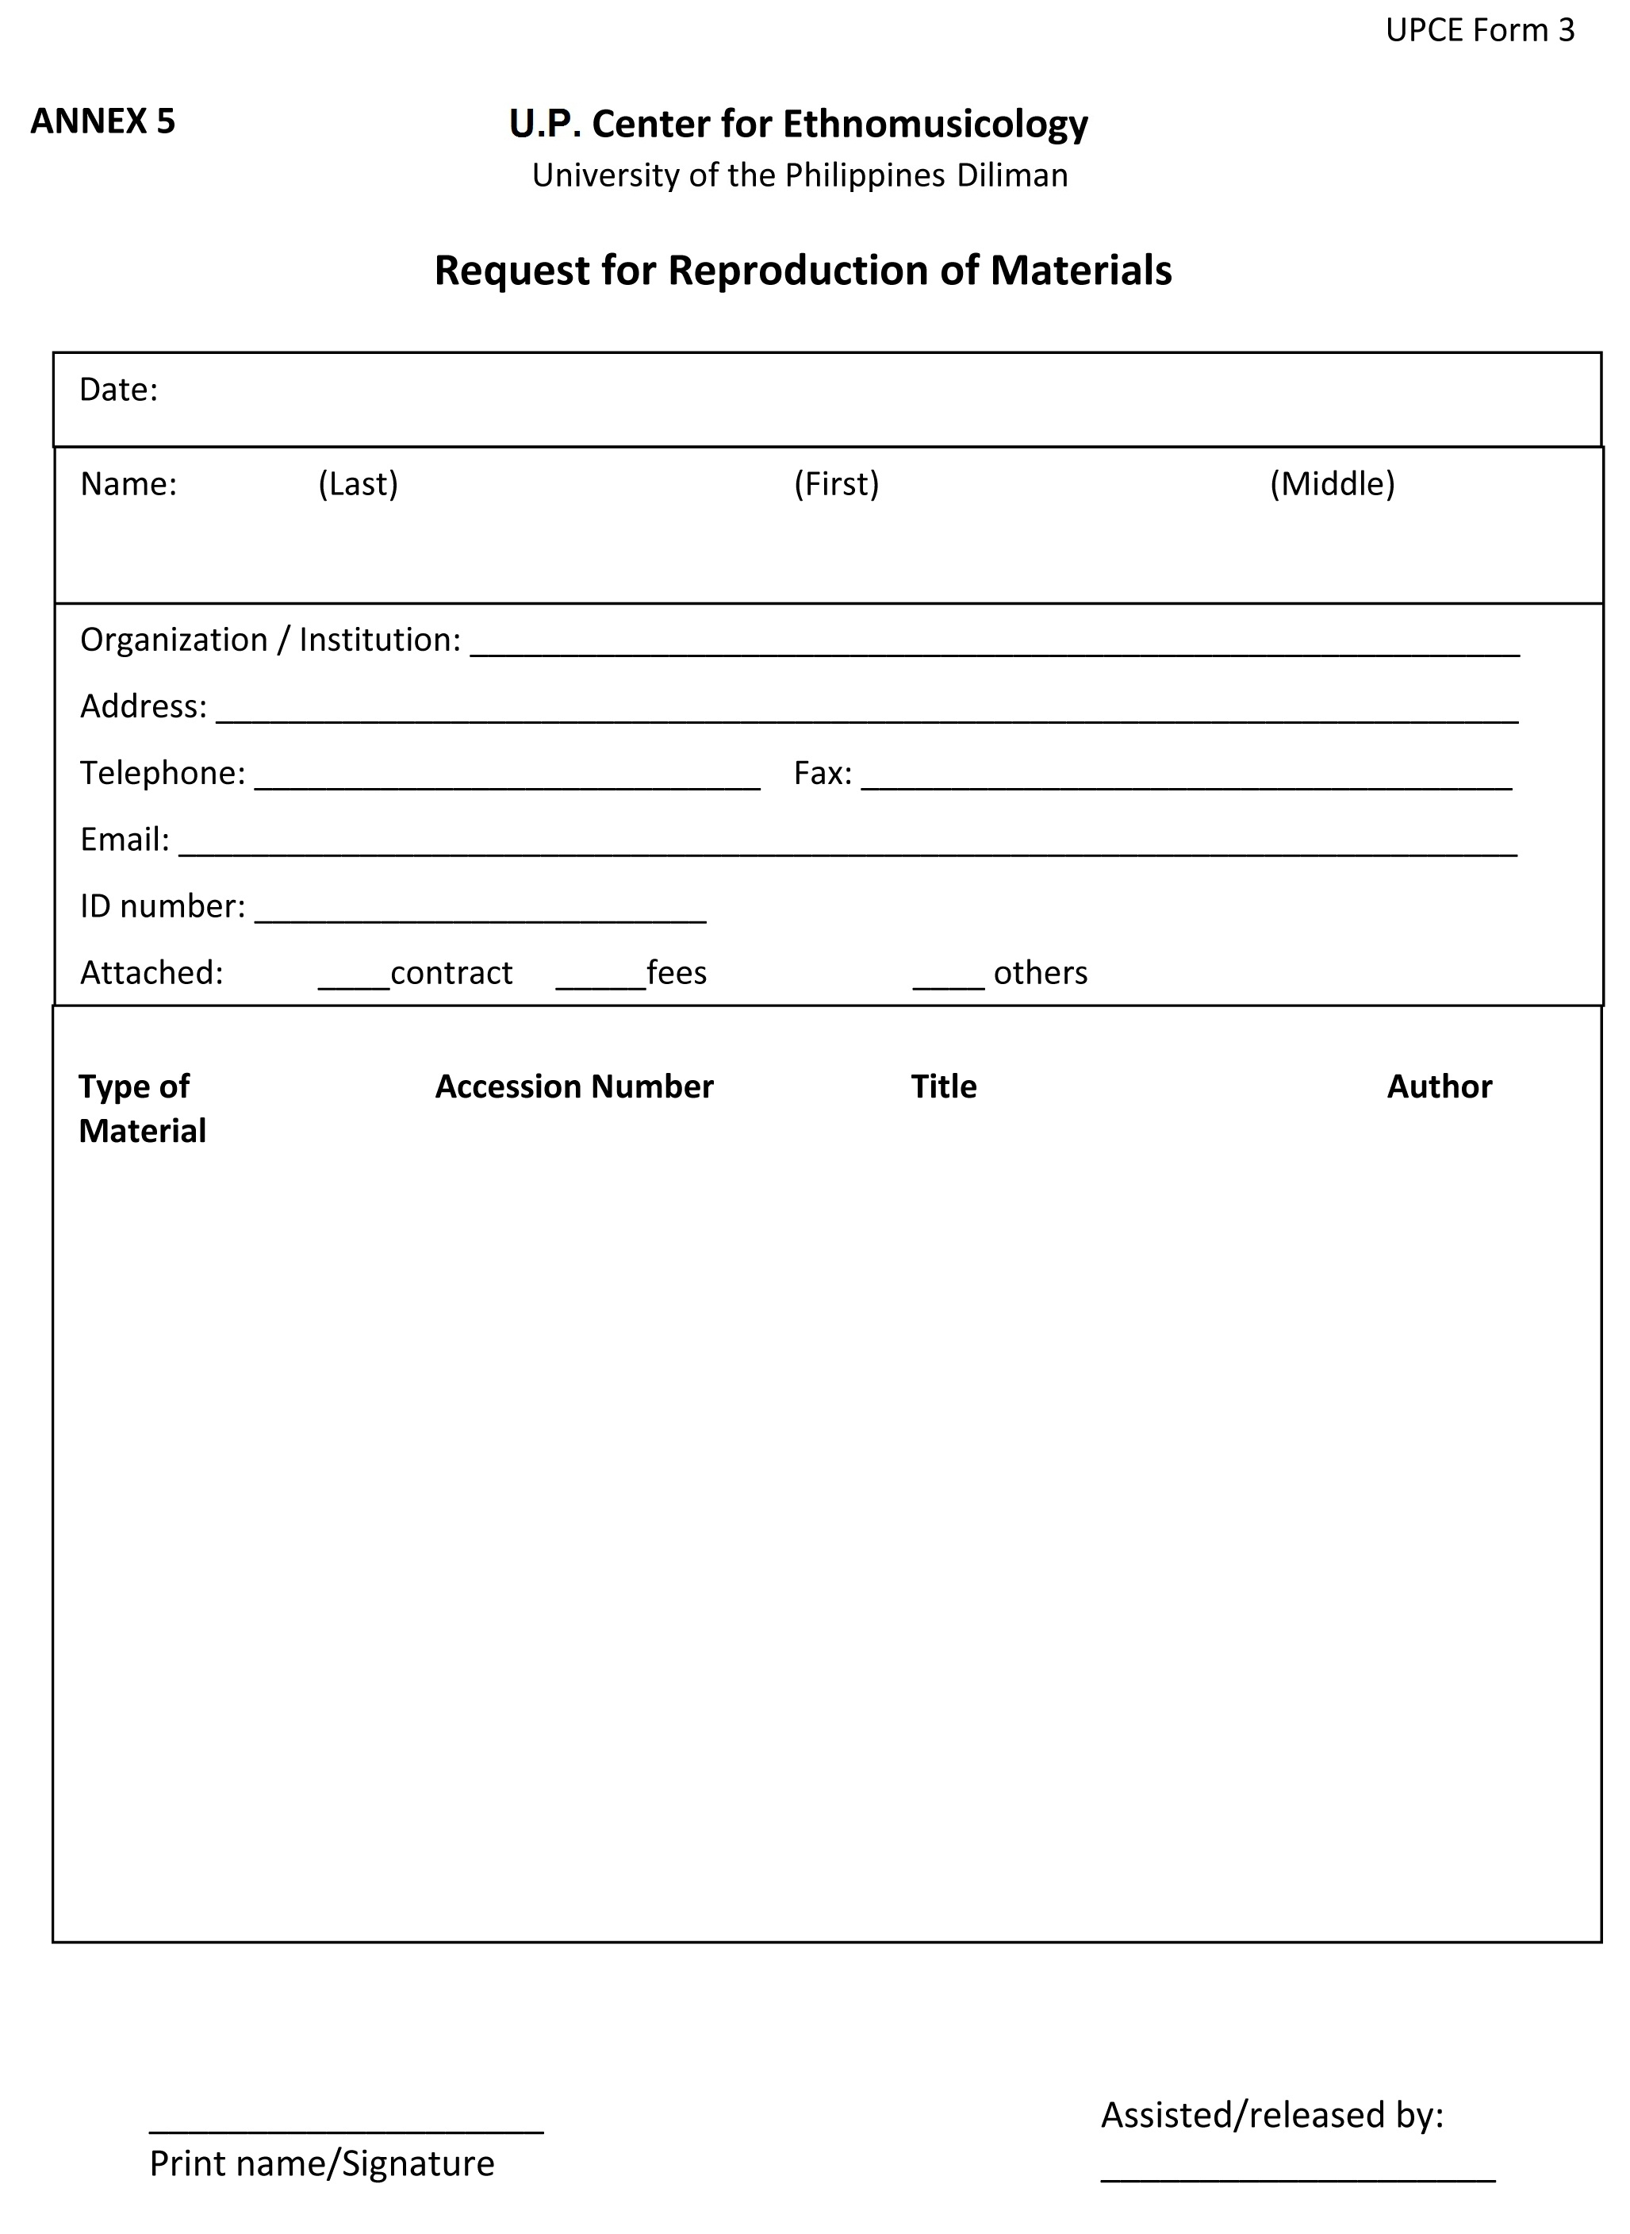

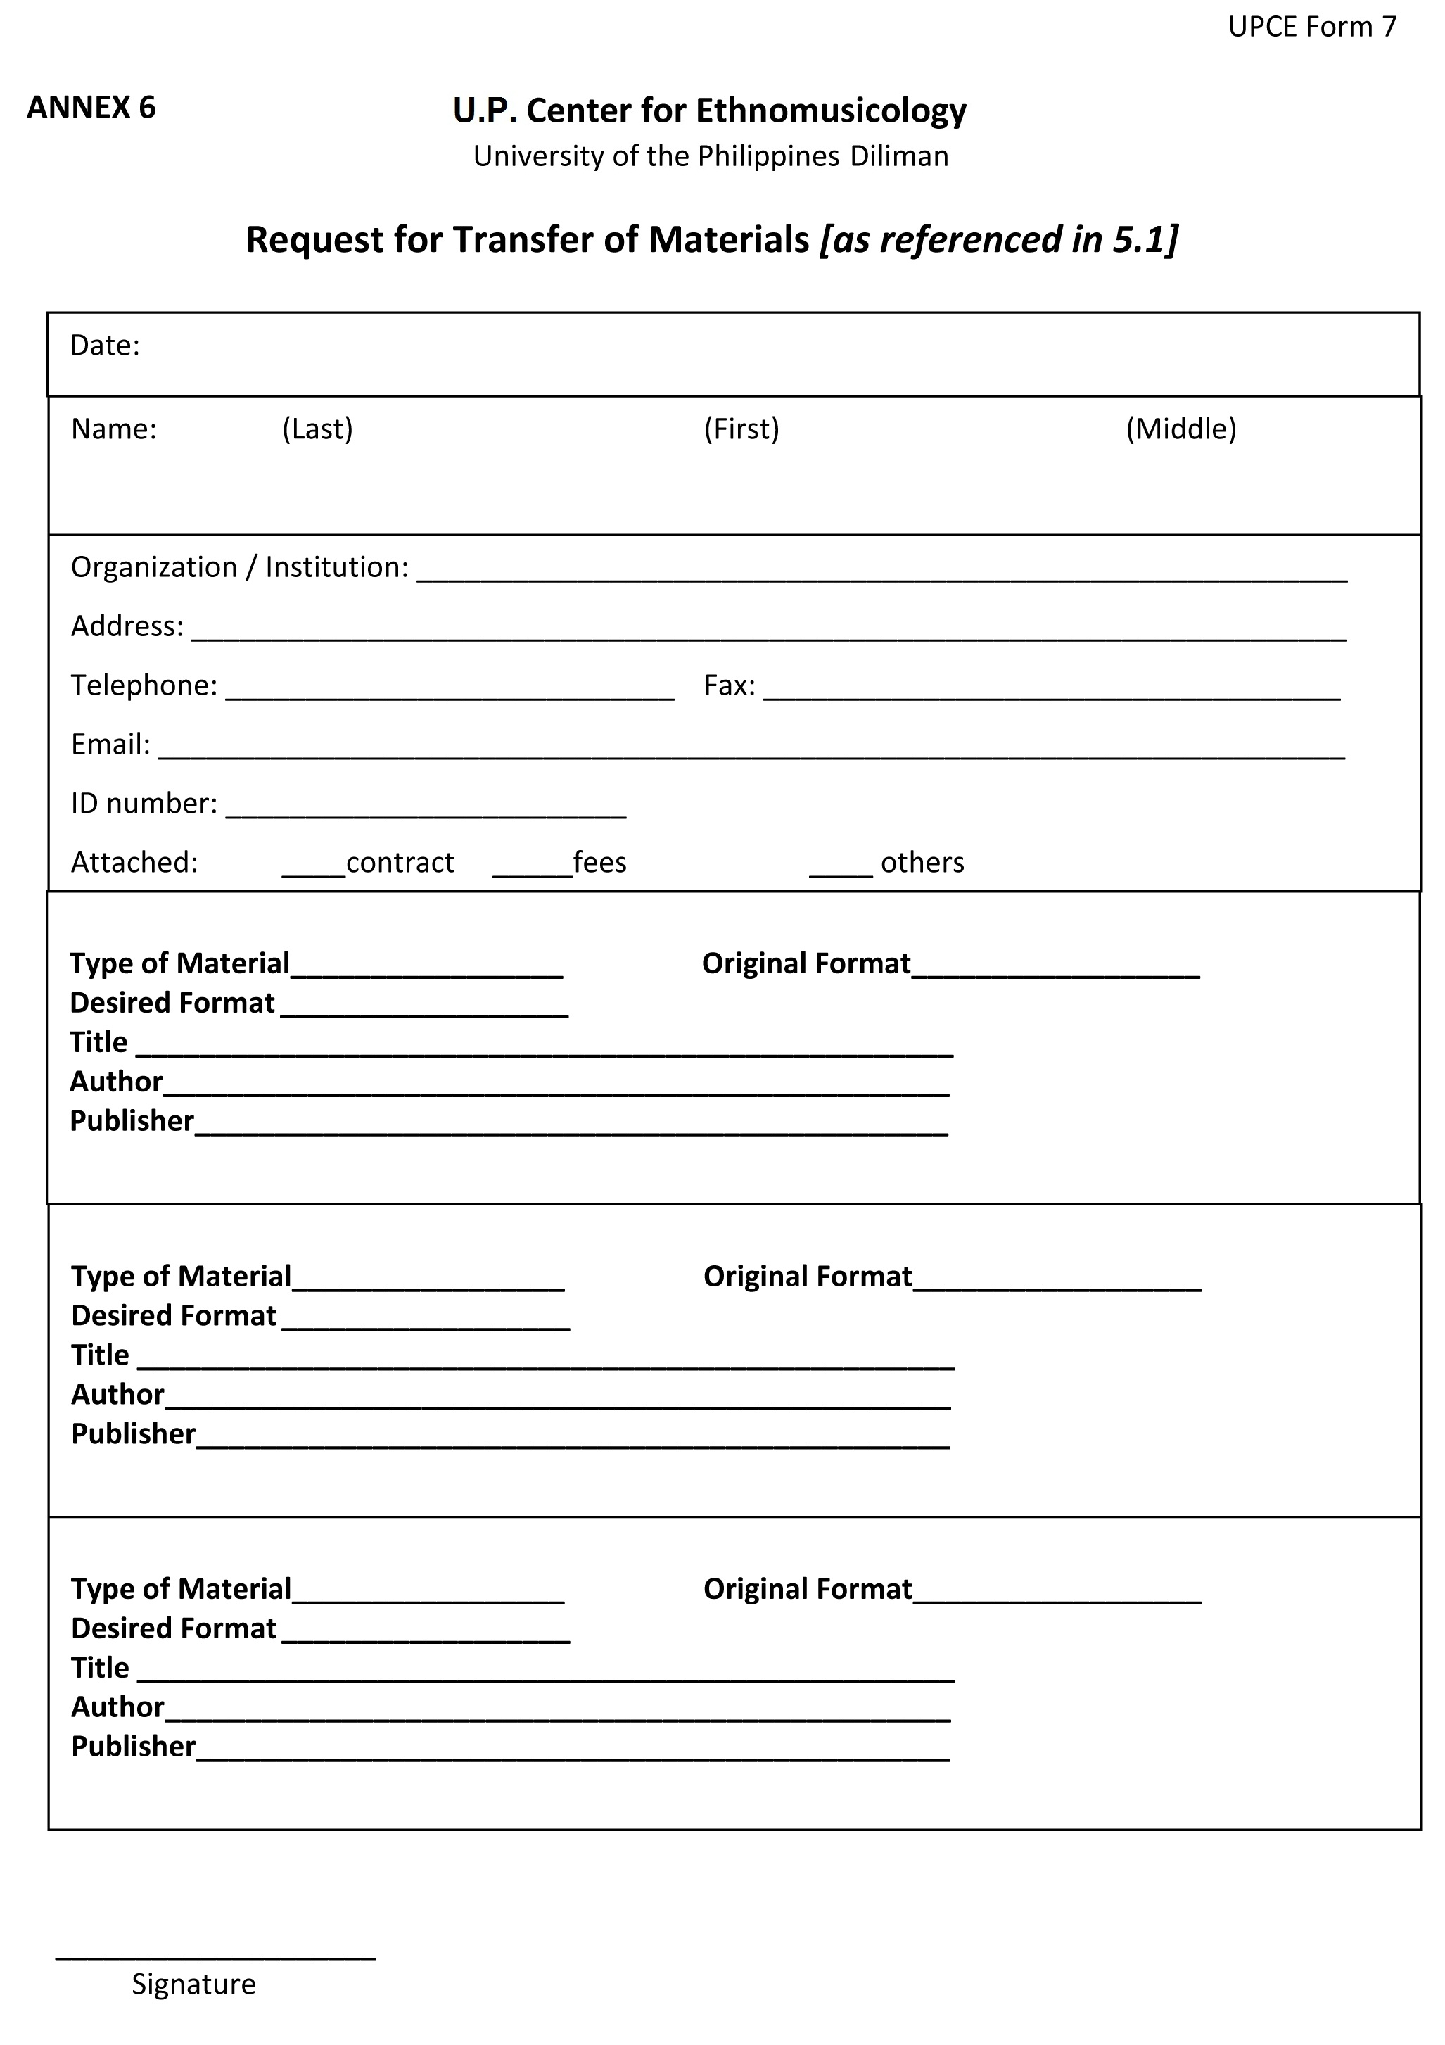

ANNEX 7



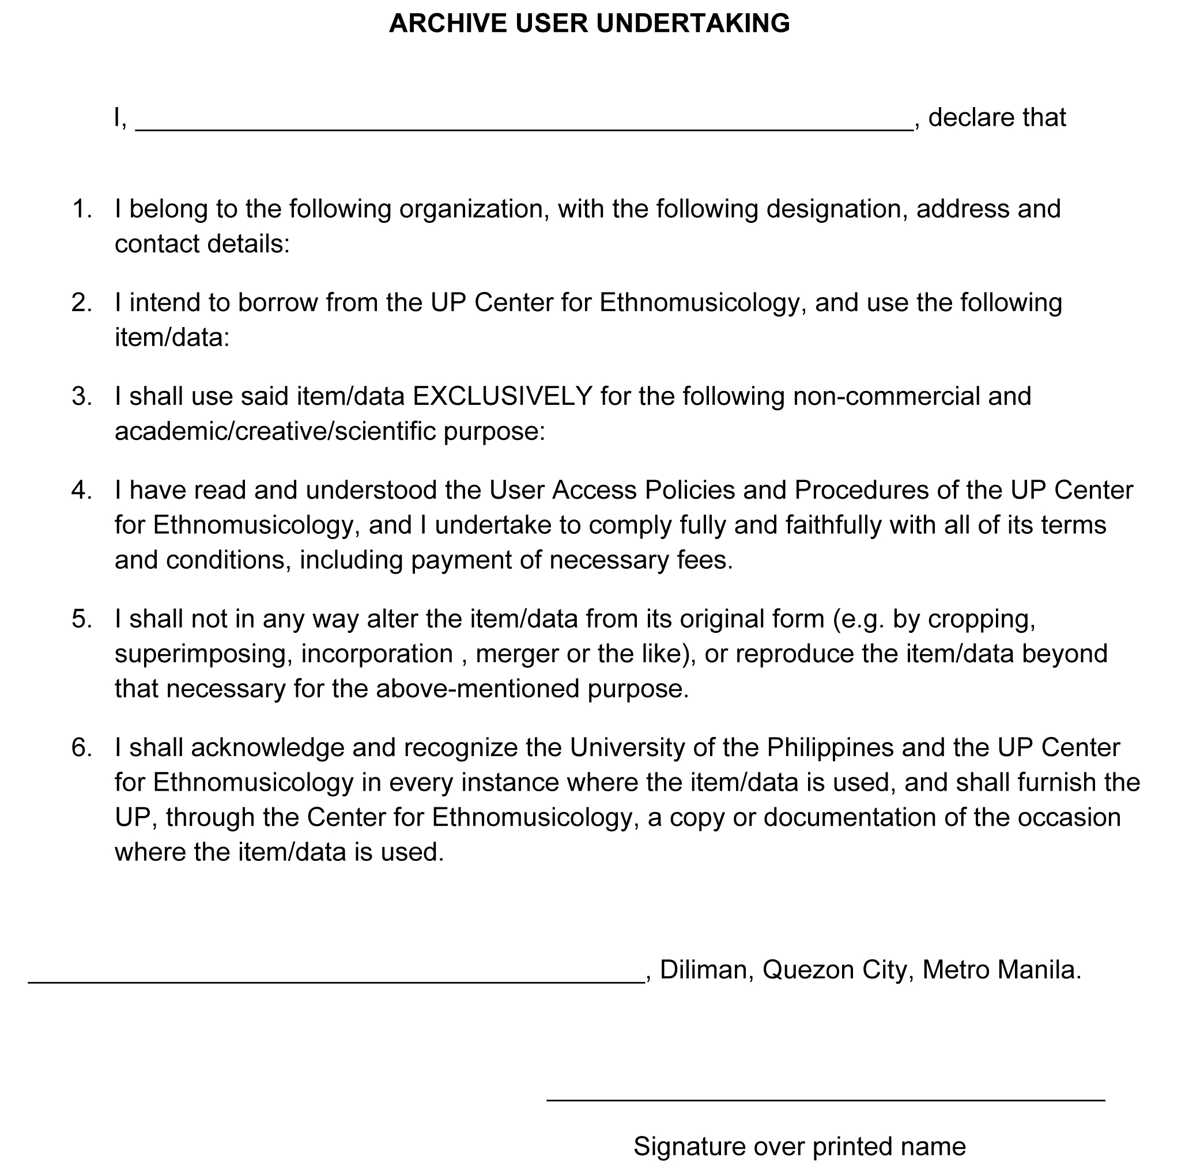

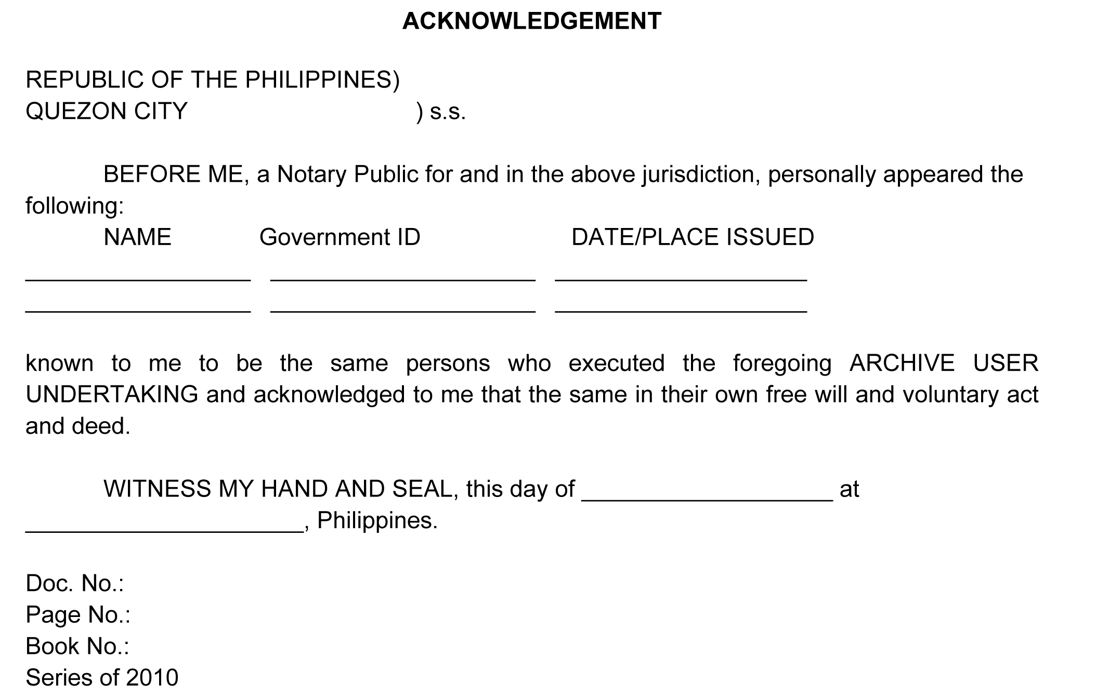
ANNEX 8: Fees for Access

Product/Service | UP |  | Non-UP | Foreign | Justification | Price Comparison
 | Classroom  Use | Non-Class Use/ Alumni
Access Fees (access only) | Free | 50/visit | 200/  Appoint-ment | 500/  Appoint-ment | Similar to UPCOE Library fee and RMAO | College of EngLib  50/day  500/sem  Natl Archives  200 annual fee or 100/visit;  40/visit

ANNEX 9: Fees for borrowing of instruments

Product/Service | UP |  | Non-UP | Foreign | Justification | Price Comparison
Instruments | Classroom  Use | Non-Class Use/ Alumni
Bamboo & wood | Free | 20% of the cost of instrument per use | 30% of the cost of instrument per use | Not allowed | For handling. In this case therefore, borrowers will be assessed by the Executive Director before the instruments are brought out of the UPCE. In the first place, the Executive Director and staff of UPCE already know most borrowers of the instruments. | College of EngLib  50/day  500/sem
Brass/Metal  (Tamtam/  gangsa/gong) | Free | 20% of the cost of instrument per use | 30% of the cost of instrument per use | Not allowed |  | Natl Archives
String | Free | 20% of the cost of instrument per use | 30% of the cost of instrument per use | Not allowed |  | 200 annual fee or 100/visit;  40/visit

ANNEX 10: Fees for reproduction of scores

Product/Service | UP |  | Non-UP | Foreign | Justification | Price Comparison
Reproduction of Scores | Classroom  Use | Non-Class Use/ Alumni
Full score | Printing cost +100 | Printing cost +300 | Printing cost +500 | Printing cost +1,000  (non-partners) +500 for partners* | Duplication will be done in commercial shops. Actual copying cost cannot be determined as the size of the scores varies. Additional charges, i.e. 100, 300, 500, 1000 will cover the cost of transportation, binding, packaging, & mailing. For mailing, any amount over the stated charge will be covered by researcher. | We found no other UP unit/research institutions who offer this service.
Part scores (1 copy for each part) | Printing cost +100 | Printing cost +300 | Printing cost +500 | Printing cost +1,000  +500
Published page (photocopy per page; maximum of 10 pages per research day) | 1.00 | 1.50 | 2.00 | 2.00



